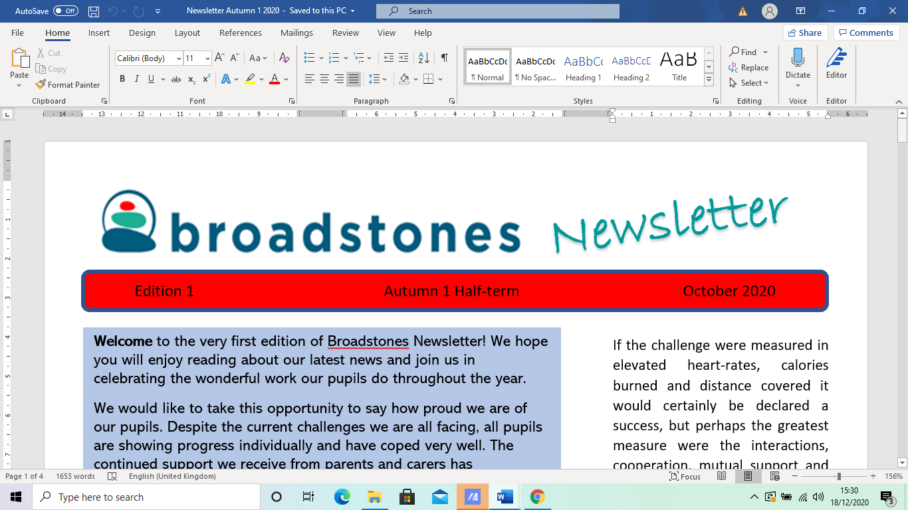



***Welcome to Broadstones School’s Spring 1 newsletter.***

***In this term’s exciting edition, we bring you details of:***

***some of the great work carried out around***

***Hate Crime Awareness Week.***

***A reminder of the Parents / Carers social event held at The Midway.***

***The winner of the £20 Amazon gift voucher literacy challenge.***

***as well as the usual catch up information from some of our curriculum areas.***

**Hate Crime Awareness Week**

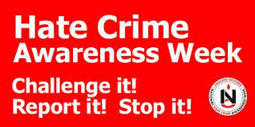

Greater Manchester Hate Crime Awareness Week took place from the *3rd* to the *7th of* February and is recognised each year by the ten boroughs that make up Greater Manchester County, promoting a message of a county that is ‘Too Great for Hate’.

To raise awareness of this important initiative, various activities took place across our curriculum areas.

In English, pupils looked

at the famous poem: *What Stephen Lawrence*

*Has Taught Us* by the

highly respected and sadly recently passed away

dub poet Benjamin Zephaniah.

The poem tells the story of police corruption, institutional racism and hate crime in its worst form - the murder of an innocent schoolboy simply waiting at a bus stop.

Pupils also learned about the murdered schoolgirl Sophie Lancaster, who was targeted simply because of the way she chose to dress.

Our pupils were reminded that empathy, tolerance and compassion cost nothing and help make the world a better and safer place for all of us***.***

**Parents / Carers Event**

Another parents / carers event was scheduled for Friday 14th February.

The Midway in Stockport was again the venue used to enable parents and carers to meet up with staff, to catch up on their child’s progress and to also meet up with other parents and carers.

A great opportunity for the chance to check up on their child’s wellbeing, happiness and overall educational success.

**English with Davina**



The literacy challenge for this term involved pupils completing an extended homework project designed to help them develop a better understanding of figurative language.

This links with pupils’ individual literacy targets for this term which focused on idioms.

Many young people struggle

with figurative language, particularly autistic children who tend to take statements at face value.

The aim was to reinforce

some of the common everyday phrases that are meant to be understood in a non-literal sense and that enrich our language greatly.

And back to the winner of the voucher:

Skye. Skye won the voucher because of the quality of, and the effort that went into, completing the various tasks. Her creative writing piece on liminal spaces was particularly impressive.

Writing about the world from the perspective of a teenage girl in the 21st century, Skye wrote: ‘*the sky is no longer blue and clean, but a sheet of grey filled with toxic gases.’*

Skye’s use of figurative language is impressive and striking - capturing the interesting dichotomy between the expectations and possibilities, yet often trials and tribulations, of those complex teenage years. Well, done Skye, excellent prose!

A call out to Charlie, also, our school ambassador, who came a very close second place

**PSHE**

**with Amy**

The Year 11 PSHE group attended the Portland Basin Museum, located in Ashton-Under-Lyne, and housed within the 19th century Canal Warehouse.

The museum covers the area's industrial heritage, which offers our pupils the chance to explore the history and culture of the region**.**

The museum features exhibits that interpret aspects of local history, industry and trades, including a 1920s period street with shops, period room displays and historic machines**.**

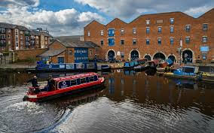

**One of the barges used to give a mini cruise experience to members of the public**

**Science with Claire**

Some of our pupils have been making concrete from cement, sand and aggregate.

They have been investigating which proportions of each chemical will give the strongest concrete by hanging a bucket on the concrete rod and adding half bricks to it. The strongest mix tested so far was 1 part cement, 2.5 parts sand and 3 parts aggregate.

The pupils also realised that they do need to mix the concrete very well otherwise there may be a fault in the rod.

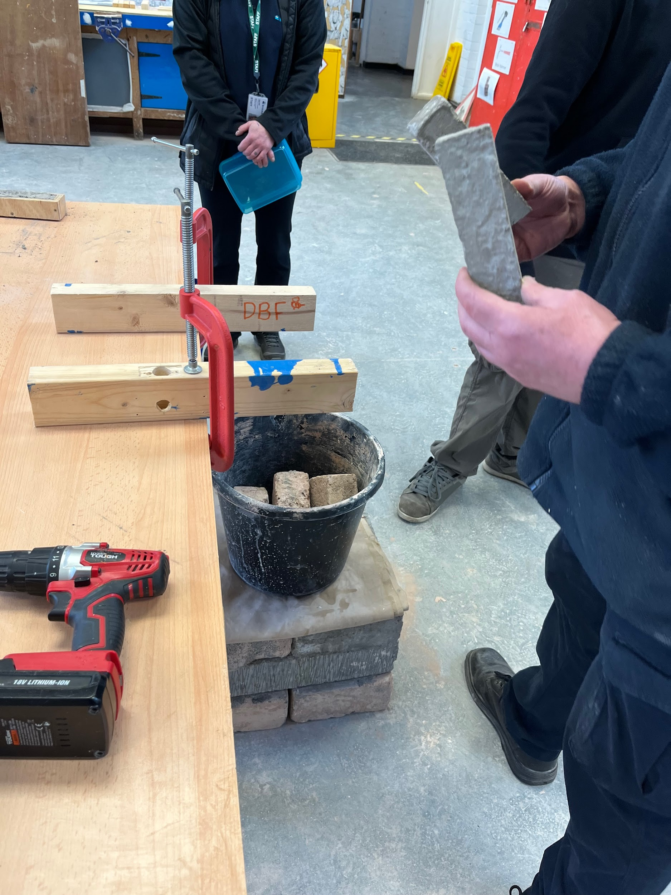

**Jamie, Kayden and Rocky making concrete**

Meanwhile, Charlie has also been using some familiar toys to work out some energy transfers. For example, the wind-up train: elastic potential energy

transfers mechanically to kinetic energy and also heat and sound as waves which are dissipated into the environment.

Fan: chemical energy is

transferred electrically to kinetic energy and also heat and sound as waves which are dissipated into the environment.

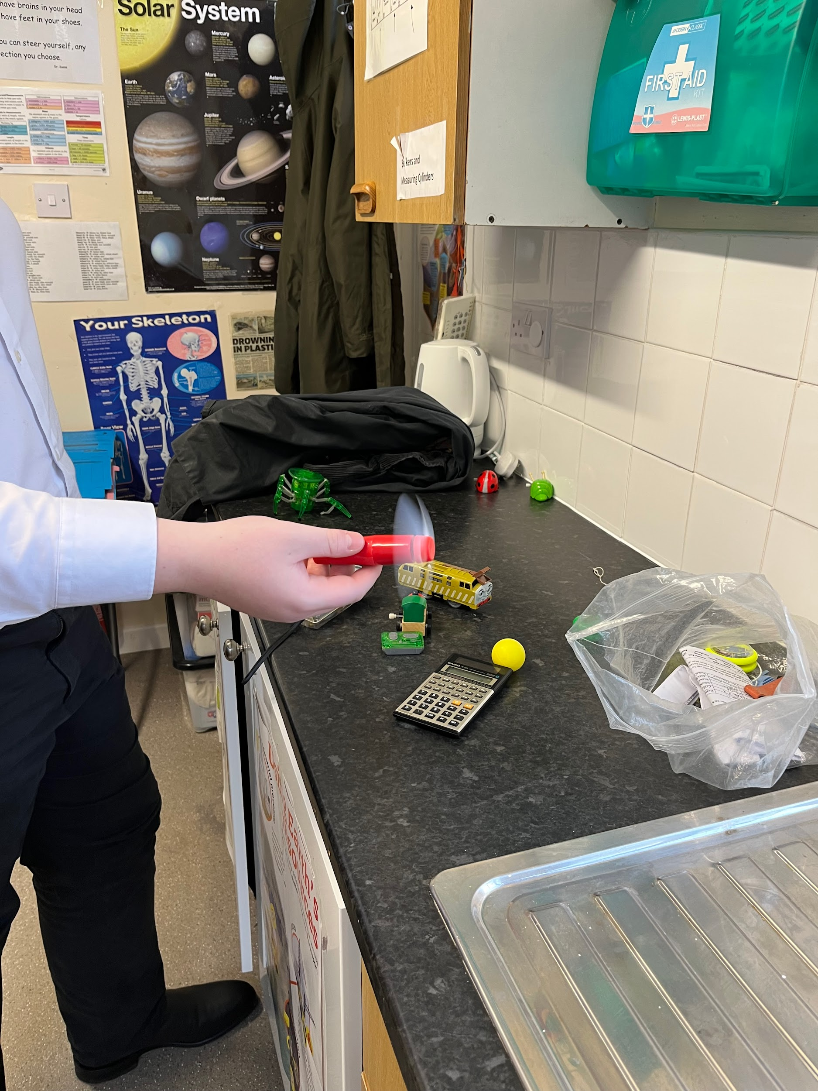

**Charlie looking at different energy transfers**

**Bird Watch in the Salon**

Over at the salon, their resident pigeon, after three weeks of nesting, has now introduced her two chicks to the world.

Eager to name them before they fly the nest, Claudia and Clare have asked staff and pupils to consider suitable names for them.

But there is to be no winging it here. Peck-tacular names only please.

Davina has suggested Percey and Patricia, liking the alliterative link. However, these names won’t necessarily take flight as they are looking for names that soar above the rest.

All ideas straight to Claudia and Clare please who put out a joint statement: ‘We

are honoured to name these birds. The mother did not

get into a flap or seem to have her feathers ruffled at all, she just laid the eggs, nested nicely and now weans her chicks until they are ready to fly the nest. We interpreted some of her cooing as a cry for help in naming the chicks - which is why we are doing this.’

Great work salon staff. Let’s hope you don’t get a load of bird brained ideas but real highflying nominations.

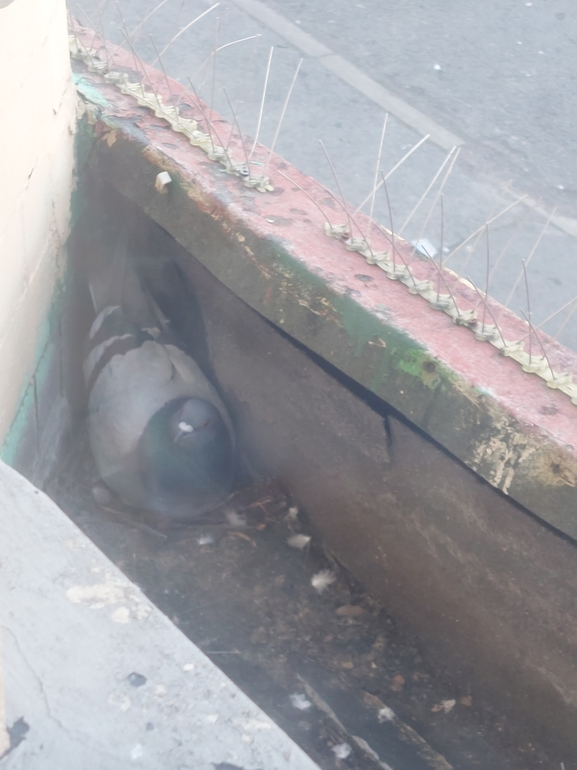

**Mother and babies nesting at the salon**

And on a different note, pupils celebrated culture with nail art. Nail art is more than just polish - it’s an expression of one’s personality and creativity. A way to celebrate those special moments in life.

So, whether it’s classic pinks and reds, playful hearts or inspiring messages, make a statement with culture nail art this Chinese New Year and Valentine’s Day.

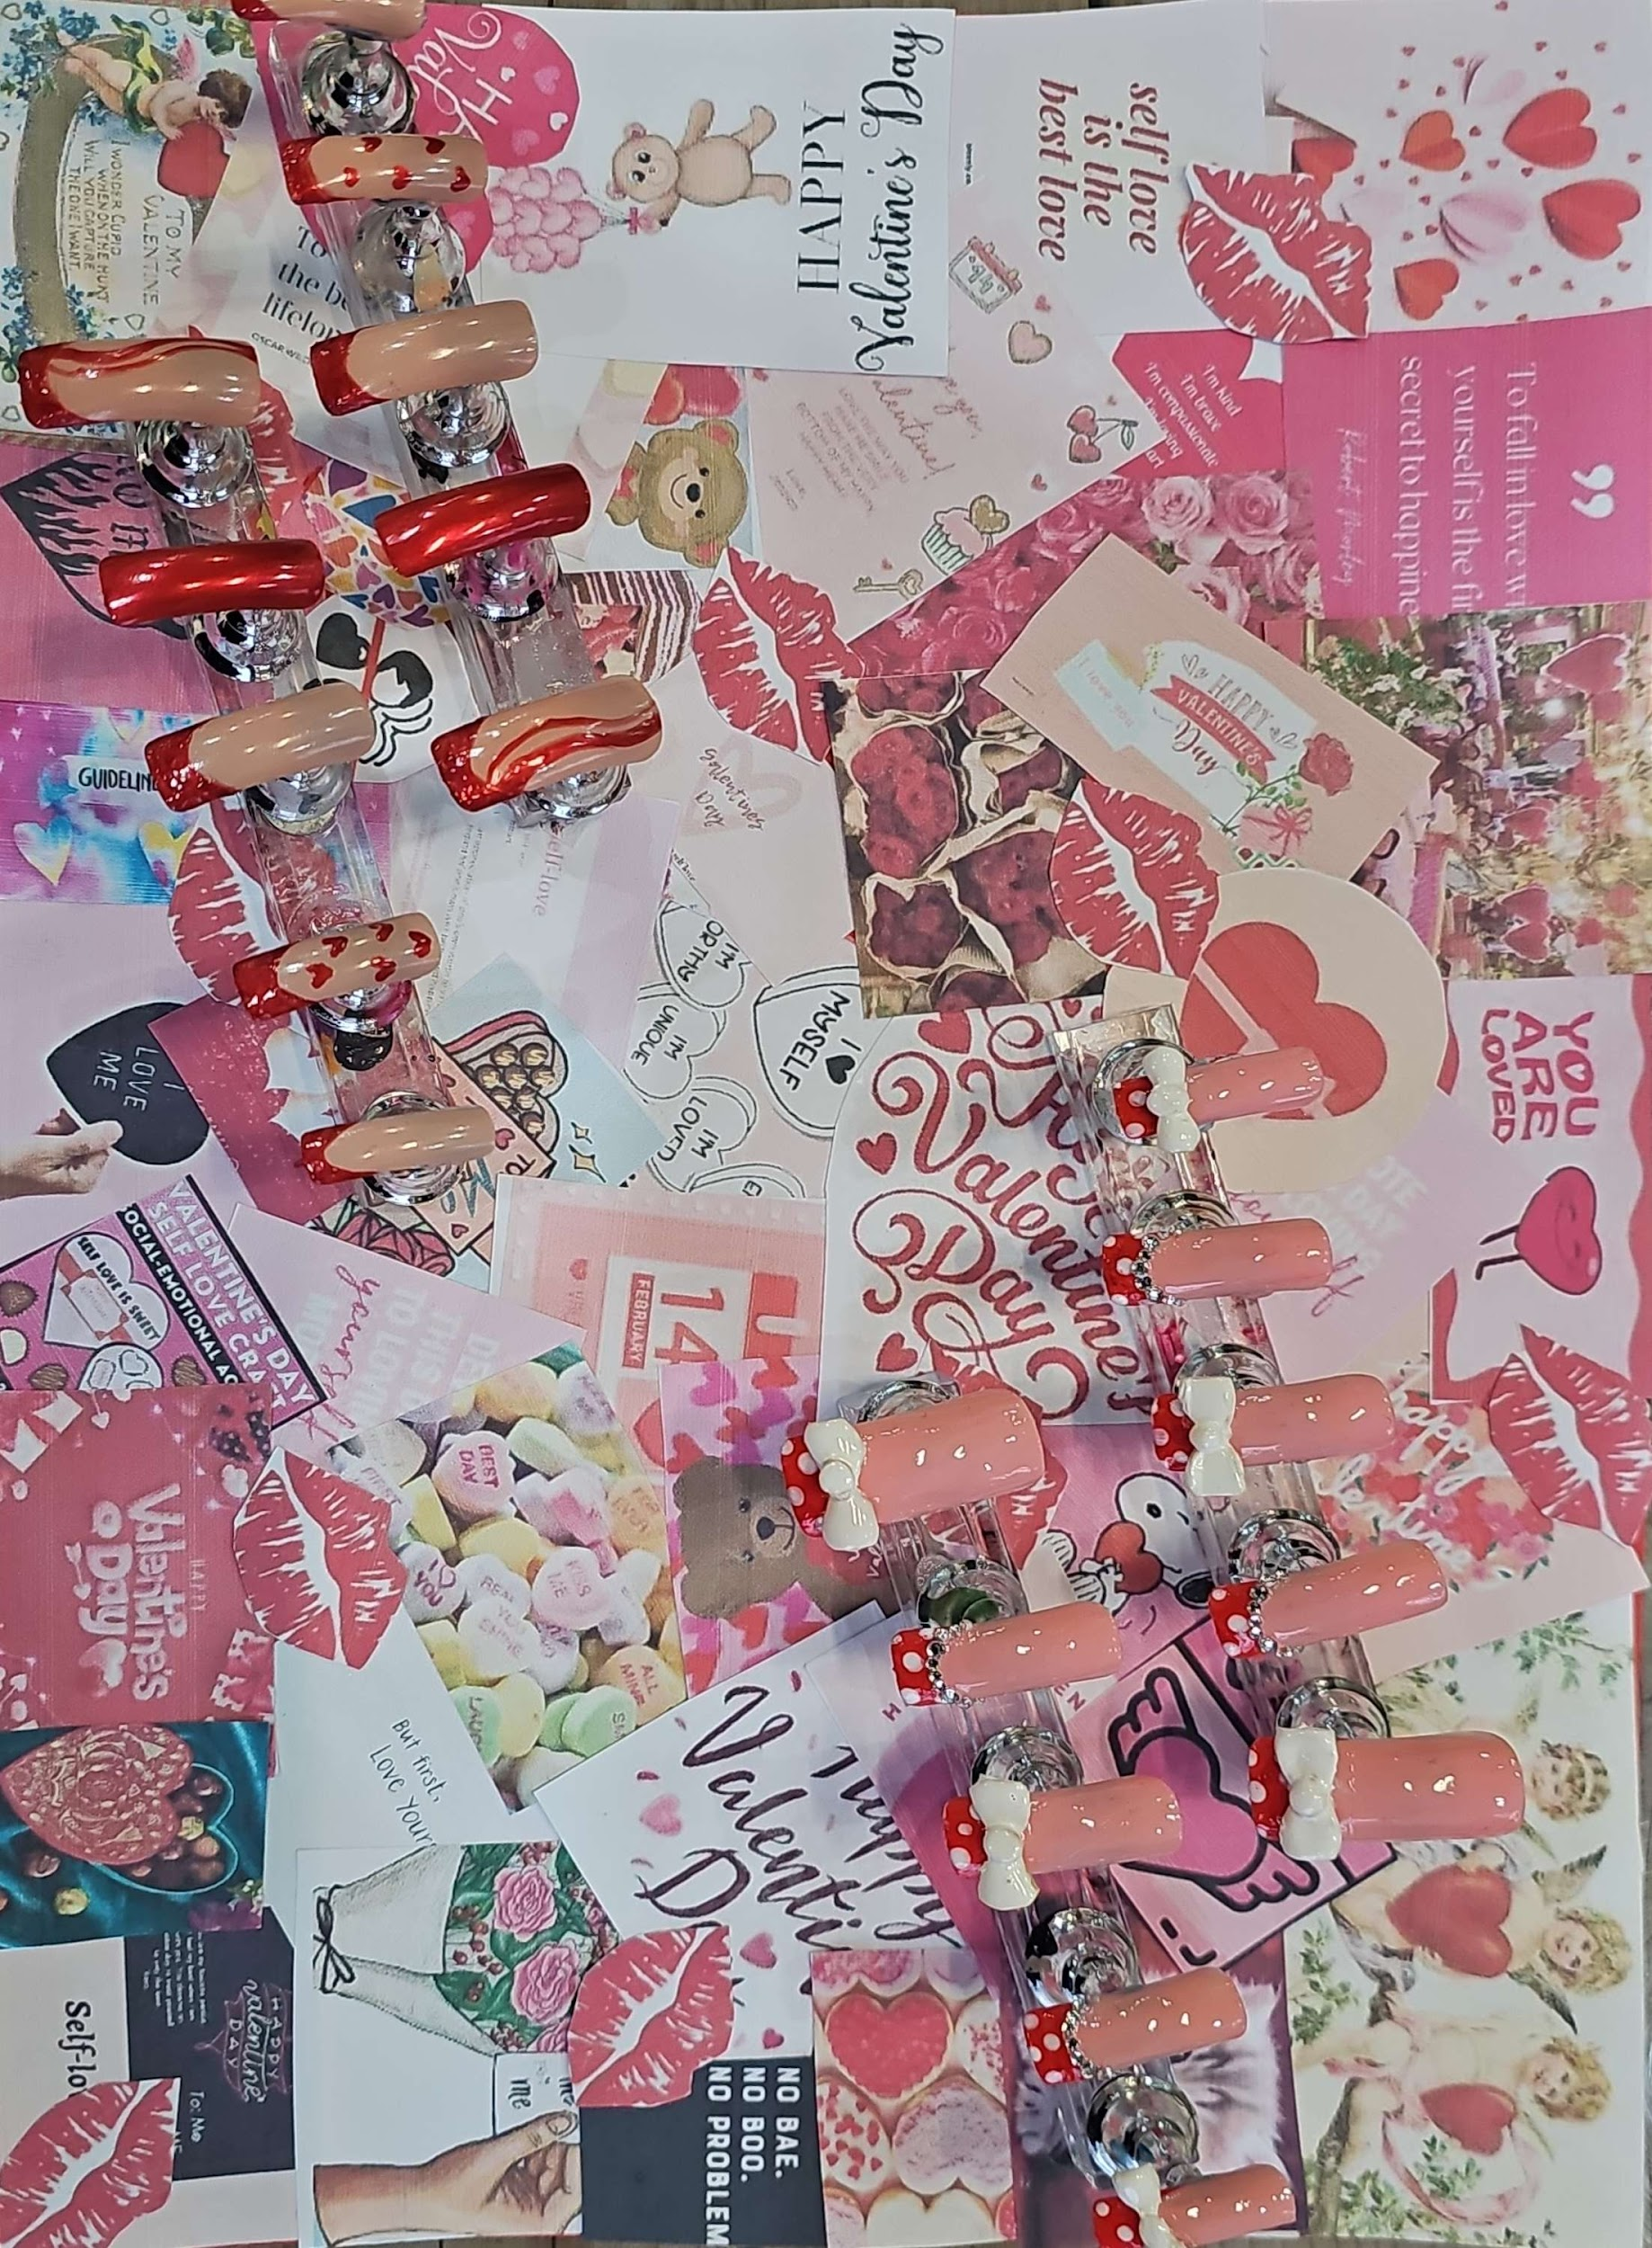

**Culture nail art at the salon**

**Any other business…**

**"The Chartered Trading Standards Institute has issued a warning that imported sweets and fizzy drinks with known links to hyperactivity and cancer have flooded the UK.**

**Manchester City Council are taking this very seriously, and the Council’s Environmental Health team are seizing illegal products from local shops. They’re also urging you not to buy these products for children."**

[**https://www.tradingstandards.uk/media/3181085/final-version-illegal-american-sweets-and-drinks-warning-flyer.pdf**](https://www.tradingstandards.uk/media/3181085/final-version-illegal-american-sweets-and-drinks-warning-flyer.pdf)



Co-Editor Charlie, School Ambassador

**Useful contact numbers:**

**KOOTH: (on-line mental**

**Health support for 11-18**

**Year olds);**

**MOSAIC: (Drugs & Alcohol**

**Services): 0161-218-1100;**

**MASSH: (Multi Agency**

**Safeguarding Hub):**

**0161-217-6028**